ENGLISH LINK
Beware of Annoying Head Lice
By Kim Nymark
It seems lice are synonymous with ‘Back to School’. Since it is that time of the year, I thought it would be appropriate to discuss these creepy-crawly pests.
The head louse is a tiny, wingless parasitic insect that lives among human hairs and feeds on tiny amounts of blood drawn from the scalp. Lice (the plural of louse) are a very common problem, especially for kids. They're contagious, annoying, and sometimes tough to get rid of. But while they're frustrating to deal with, lice aren't dangerous. They don't spread disease, although their bites can make a child's scalp itchy and irritated, and scratching can lead to infection. It's best to treat head lice quickly once they're found because they can spread easily from person to person. They can't fly or jump. They spread mainly through head-to-head contact, but sharing clothing, bed linens, combs, brushes, and hats also can pass them along. Pets can't catch head lice and pass them on to people or the other way around.
Although they're very small, lice can be seen by the naked eye. Look for the lice eggs (called nits). Nits look sort of like dandruff, only they can't be removed by brushing or shaking them off.
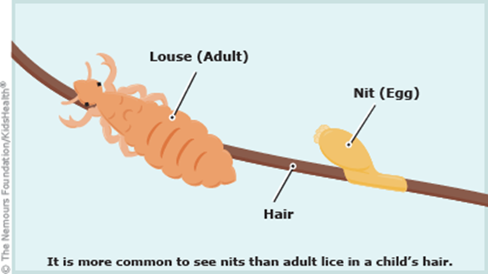
Lice eggs hatch within 1 to 2 weeks after they're laid. After hatching, the remaining shell looks white or clear and stays firmly attached to the hair shaft. Lice can survive up to 2 days off the scalp. With lice bites usually comes itching and scratching. This is actually due to a reaction to the saliva of lice. It can sometimes take weeks for kids with lice to start scratching. They may complain, though, of things moving around on or tickling their heads.
In Canada, 3 insecticides are approved to treat head lice: pyrethrin (R&C Shampoo and Conditioner), permethrin (Nix Creme Rinse or Kwellada-P Creme Rinse), and lindane (Hexit Shampoo or PMS-Lindane Shampoo). Pyrethrin and permethrin are safe when used on humans. However, lindane can be toxic and should not be used on infants or children younger than 2 years of age. It's important to follow the directions exactly because these products are insecticides.
Here are some simple ways to get rid of the lice and their eggs, and help prevent a lice reinfestation:
- Wash all bed linens and clothing in very hot water (130°F [54.4°C]), then put them in the hot cycle of the dryer for at least 20 minutes.
- Dry clean anything that can't be washed (like stuffed animals). Or put them in airtight bags for at least 3 days.
- Vacuum carpets and any upholstered furniture (in your home or car), then throw away the vacuum cleaner bag.
- Soak hair-care items like combs, barrettes, hair ties or bands, headbands, and brushes in rubbing alcohol or medicated shampoo for 1 hour.
If you discover that your child does indeed have lice or nits, contact the staff at school or childcare center to let them know. It is important to find out what their return policy is. For complete details on head lice, go to: http://bit.ly/1Izb3H8 .
kim@4kornerscenter.org for the English Communities Committee of the CSSS des Sommets and 4 Korners Family Resource Center: 1-888-974-3940 or 819-324-4000 ext. 4330.

